SMART HOME AUTOMATION USING ESP8266

# A PROJECT REPORT

***submitted by***

**VIDHIYA S B -210701306**

**VARUSHA S -210701304**

***in partial fulfillment for the award of the degree of***

**BACHELOR OF ENGINEERING**

***in***

# COMPUTER SCIENCE AND ENGINEERING



**RAJALAKSHMI ENGINEERING COLLEGE,**

**ANNA UNIVERSITY : CHENNAI 600 025**

# MAY 2024

RAJALAKSHMI ENGINEERING COLLEGE, CHENNAI

**BONAFIDE CERTIFICATE**

Certified that this project report titled “**SMART HOME AUTOMATION SYSTEM USING ESP8266”** is the bonafide work “**VIDHIYA S B -210701306,VARUSHA S -210701304”** who carried out the work under my supervision. Certified further that to the best of my knowledge the work reported herein does not form part of any other thesis or dissertation on the basis of which a degree or award was conferred on an earlier occasion on this or any other candidate.

# SIGNATURE

Ms. S. Ponmani M.E.,MBA,

# SUPERVISOR

Assistant Professor

Department of Computer Science and Engineering

Rajalakshmi Engineering College

Chennai - 602 105

Submitted to Project Viva-Voce Examination held on

**Internal Examiner External Examiner**

# ABSTRACT

This project proposes a Smart Home Automation System (SHAS) leveraging the integration of NodeMCU microcontrollers, LEDs, breadboards, jumper wires, Blynk platform, and 5V relays. With the advent of IoT technologies, the demand for intelligent and interconnected home systems has surged, aiming to enhance convenience, efficiency, and security for homeowners. The SHAS outlined in this study harnesses the capabilities of NodeMCU, a low-cost open-source platform based on the ESP8266 Wi-Fi module, to serve as the central control unit. LEDs are utilized as indicators for various statuses and feedback within the system, providing visual cues to users. The breadboard acts as a prototyping platform, facilitating the assembly and connection of electronic components, while jumper wires enable seamless interfacing between different elements of the system.

The proposed SHAS offers a flexible and scalable solution for implementing smart home automation, catering to the diverse needs and preferences of users. By leveraging the combined functionalities of NodeMCU, LEDs, breadboards, jumper wires, Blynk platform, and 5V relays, the system provides an intuitive and accessible interface for users to monitor and manage their home environment remotely. The integration of these components lays the foundation for future advancements in smart home technology, offering enhanced automation, energy efficiency, and convenience for homeowners.

# ACKNOWLEDGEMENT

First, we thank the almighty God for the successful completion of the project. Our sincere thanks to our chairman **Mr. S. Meganathan, B.E., F.I.E.,** for his sincere endeavor in educating us in his premier institution. We would like to express our deep gratitude to our beloved Chairperson **Dr. Thangam Meganathan, Ph.D.,** for her enthusiastic motivation which inspired us a lot in completing this project, and Vice-Chairman **Mr. Abhay Shankar Meganthan**, **B.E., M.S.,** for providing us with the requisite infrastructure. We also express our sincere gratitude to our college principal, **Dr.S.N.Murugesan M.E., PhD.,** and **Dr. P. Kumar M.E., Ph.D., Head of the Department of Computer Science and Engineering,** and our project guide **Ms. S. Ponmani M.E.,MBA,** for her encouragement and guiding us throughout the project. We would like to thank our parents, friends, all faculty members, and supporting staff for their direct and indirect involvement in the successful completion of the project for their encouragement and support.

|  |  |  |
| --- | --- | --- |
| **CHAPTER NO.** | **TITLE**  **TABLE OF CONTENTS** | **PAGE No.** |
|  | **ABSTRACT** | **iii** |
|  | **INTRODUCTION** | **1** |
|  | 1.1 Motivation | **2** |
|  | 1.2 Objectives | **2** |
|  | **LITERATURE REVIEW** | **3** |
|  | 2.1 Existing System | **4** |
|  | 2.1.1 Advantages of the existing system | **4** |
|  | 2.1.2 Drawbacks of the existing system | **4** |
|  | 2.2 Proposed system | **5** |
|  | 2.2.1 Advantages of the proposed system | **5** |
| **3.** | **SYSTEM DESIGN** |  |
|  | 3.1 Development Environment | **6** |
|  | 3.1.1 Hardware Requirements | **6** |
|  | 3.1.2 Software Requirements | **7** |
| **4.** | **PROJECT DESCRIPTION** | **8** |
|  | 4.1 System Architecture | **8** |
|  | 4.2 Methodologies | **9** |
| **5.** | **RESULTS AND DISCUSSION** | **10** |
| **6.** | **CONCLUSION AND FUTURE WORK** | **11** |
|  | 6.1 Conclusion | **11** |
|  | 6.2 Future Work | **11** |
|  | **APPENDIX** | **12** |
|  | **REFERENCES** | **15** |

**CHAPTER 1**

**INTRODUCTION**

The rapid evolution of Internet of Things (IoT) technologies has spurred innovations in various domains, including the realm of home automation. Smart Home Automation Systems (SHAS) have emerged as a promising solution to enhance the convenience, efficiency, and security of modern living spaces. This project focuses on the development of a SHAS utilizing a combination of hardware components and software platforms to create an intelligent and interconnected home environment. At the core of this system lies the NodeMCU microcontroller, a versatile and cost-effective platform capable of Wi-Fi connectivity and GPIO control. By integrating NodeMCU with components such as LEDs, breadboards, jumper wires, Blynk platform, and 5V relays, the project aims to empower homeowners with remote monitoring and control capabilities over various aspects of their home, ranging from lighting and temperature to security and appliance automation. This introduction sets the stage for exploring the technical details and practical implementation of the proposed SHAS, showcasing its potential to revolutionize modern living through IoT-driven automation and connectivity.

The seamless integration of hardware components with cloud-based platforms like Blynk enables real-time monitoring and control from anywhere with an internet connection. Furthermore, the modular nature of the system allows for scalability and expansion as the needs of the user evolve over time.

# 1.1 Motivation

•**Enhanced Home Management**: Traditional home management methods can be cumbersome, involving manual control of various devices and systems. Smart home automation systems offer an efficient solution by centralizing control and allowing users to remotely manage their home environment.

•**Elevated Comfort and Convenience:** By integrating IoT technologies like NodeMCU and Blynk, homeowners can enjoy a more comfortable and convenient living experience. They can remotely adjust lighting, temperature, and security settings with ease, eliminating the need for manual adjustments.

•**Improved Energy Efficiency**: Smart home automation systems contribute to energy conservation by enabling users to optimize energy usage based on their preferences and occupancy patterns. This leads to reduced energy consumption and lower utility bills, aligning with sustainable living practices.

**1.2 Objectives**

* **Integration of Hardware and Software:** The primary objective of this project is to seamlessly integrate hardware components such as NodeMCU, LEDs, breadboards, jumper wires, and 5V relays with software platforms like Blynk to create a cohesive smart home automation system.
* **Remote Monitoring and Control:** Another key objective is to enable users to remotely monitor and control various aspects of their home environment, including lighting, temperature, and security, using the Blynk mobile application.
* **Scalability and Flexibility:** The project aims to design a scalable and flexible system architecture that allows for easy expansion and customization to accommodate the evolving needs and preferences of homeowners.

# CHAPTER 2

# LITERATURE REVIEW

* **ESP8266 Home Automation Project Using NodeMCU and Blynk App by Instructables -** This project demonstrates a remote control system for home appliances using an ESP8266 board, Blynk app, and relays. It highlights functionalities like manual and app-based control, real-time feedback, and over-the-air (OTA) updates.
* **Home automation using Node MCU by SATHYABAMA -** This paper provides an overview of ESP8266, its features, and its suitability for home automation applications. It discusses NodeMCU, a popular development platform for programming ESP8266 using the Arduino IDE.
* **ESP8266 Projects on Internet of Things 2024 by IotCircuitHub:** This website curates a list of various ESP8266 projects, including home automation systems using Blynk, Tasmota, Google Assistant, and manual switches. It serves as a valuable resource for exploring different approaches.
* **A Secure and Cost-Effective Home Automation System Using ESP8266 Microcontroller" by A.A. Adewumi, S.S. Olorunshogo, A.A. Adetunbi, O.M. Olaniyi, and O.A. Ajayi (2021):** This paper delves into security considerations for ESP8266-based home automation systems. It proposes a design that incorporates encryption techniques and user authentication to protect against unauthorized access and data breaches. The paper discusses the importance of secure communication protocols and user management strategies for robust and reliable home automation systems.

# 2.1 Existing System

The existing system for this project typically involves traditional home management methods, where homeowners manually control various devices and systems within their homes. This manual approach often entails physically adjusting switches, thermostats, and security systems to meet their needs. Without any automation or remote access capabilities, homeowners are limited in their ability to monitor and control their home environment efficiently.

Moreover, the absence of real-time monitoring and control features means that homeowners have limited visibility into their home's status when they are away. They cannot remotely check if lights are left on, adjust the thermostat, or verify the status of security devices. This lack of real-time tracking makes it challenging to address issues promptly or make adjustments based on changing circumstances.

Overall, the existing system lacks the sophistication and convenience offered by smart home automation systems. It relies heavily on manual intervention, which can be time-consuming and inefficient. Additionally, without the ability to remotely monitor and control home devices, homeowners may miss out on opportunities to enhance energy efficiency, improve comfort, and bolster security.

# 2.1.1Advantages of the existing system

* **Familiarity and Ease of Use:** The existing manual home management system relies on familiar interfaces such as physical switches and knobs, which require minimal training and are intuitive for users to operate.
* **Independence from Technology:** Since the existing system does not rely on complex technological infrastructure, homeowners are not dependent on stable internet connections or the availability of compatible devices. This independence ensures continued functionality even in the absence of technology or during internet outages.
* **Top of Form**

# 2.1.2 Drawbacks of the existing system

* **Limited Remote Access:** One of the primary drawbacks of the existing manual home management system is the lack of remote access capabilities. Homeowners cannot monitor or control their home environment when they are away, leading to inconvenience and potential security concerns.
* **Lack of Automation:** Without automation features, the existing system requires manual intervention for routine tasks such as adjusting lighting, temperature, or security settings. This manual approach is time-consuming and may result in energy wastage or security vulnerabilities if devices are left unattended.
* **Reduced Efficiency**: The reliance on manual control methods makes the existing system less efficient compared to automated alternatives. Homeowners must physically operate switches, thermostats, and security systems, leading to inefficiencies and potential errors in managing their home environment.
* **Limited Integration and Compatibility**: The existing manual home management system lacks integration with modern smart devices and IoT technologies, limiting its ability to adapt to evolving home automation trends. Without compatibility with smart devices and platforms, homeowners miss out on the convenience and efficiency offered by interconnected home systems.
* **Inability to Optimize Energy Usage**: Without automation features or real-time monitoring, the existing system cannot optimize energy usage based on occupancy patterns or environmental conditions. This leads to potential energy wastage and higher utility bills compared to a smart home automation system that can intelligently manage energy consumption.

# 2.1 Proposed System

The proposed smart home automation system aims to revolutionize traditional home management methods by leveraging IoT technologies and advanced automation features. At the heart of the system lies the integration of NodeMCU microcontrollers, LEDs, breadboards, jumper wires, Blynk platform, and 5V relays, offering a comprehensive solution for remote monitoring and control of the home environment.

The proposed system offers several advantages over traditional home management methods. Firstly, it provides remote accessibility, allowing users to monitor and control their home environment in real-time from anywhere with an internet connection, enhancing convenience and security. Secondly, the system automates routine tasks such as lighting, temperature regulation, and security, reducing the need for manual intervention and optimizing energy usage.

# 2.2.1 Advantages of the proposed system

* **Convenience and Efficiency:** The proposed smart home automation system offers unparalleled convenience by enabling users to remotely monitor and control their home environment from anywhere with an internet connection. Whether adjusting lighting, regulating temperature, or checking security cameras, users can conveniently manage their home through a mobile application.
* **Energy Efficiency:** By implementing smart automation features, such as scheduling lights and appliances to operate based on occupancy patterns or energy demand, the system promotes energy efficiency. Users can optimize energy usage, reducing utility costs and environmental impact while maintaining comfort.
* **Enhanced Security:** With real-time monitoring and alerts, the smart home automation system enhances security by providing instant notifications of any suspicious activity or unauthorized access.

# CHAPTER 3

**SYSTEM DESIGN**

* 1. **Development Environment**

**3.1.1 Hardware Requirements**

* NodeMCU microcontrollers
* Orange , Red and Blue LEDs
* Breadboards
* Jumper wires
* 5V relays – 2

**ESP8266 NodeMCU microcontrollers**

Versatile and cost-effective microcontrollers with built-in Wi-Fi capabilities, serving as the central control unit for the smart home automation system.

**Breadboard**

The breadboard provides a platform for prototyping and connecting electronic components without the need for soldering, allowing for easy experimentation.

**Jumper wires**

Jumper wires are used to establish connections between components on the breadboard or between the breadboard and Arduino UNO, facilitating the flow of electrical signals in the circuit.

**Orange,Red and Green LEDs**

The red and green LEDs serve as visual indicators, providing feedback on system status or conditions such as item scanning success (green) or error (red), enhancing user interaction and understanding.

**5V relays**

Electronic switches that enable the control of high-power devices such as appliances and electronic locks, expanding the capabilities of the automation system beyond basic sensor monitoring.

Top of Form

**3.1.1Software Requirements**

* Arduino IDE
* ESP8266 Module

# CHAPTER 4

# PROJECT DESCRIPTION

The project aims to develop a comprehensive smart home automation system utilizing NodeMCU microcontrollers, LEDs, breadboards, jumper wires, Blynk platform, and 5V relays. NodeMCU serves as the central control unit, enabling Wi-Fi connectivity and GPIO control to interface with various sensors and actuators. LEDs provide visual feedback for system status, while breadboards and jumper wires facilitate secure assembly and connection of electronic components. Integration with the Blynk platform allows users to remotely monitor and control their home environment through a customizable mobile application. Additionally, 5V relays enable the control of high-power devices, expanding the system's capabilities beyond simple sensor monitoring. The project seeks to enhance convenience, efficiency, and security for homeowners by providing remote access and automation features for managing lighting, temperature, security, and other aspects of the home environment.

Top of Form

**4.1 SYSTEM ARCHITECTURE**

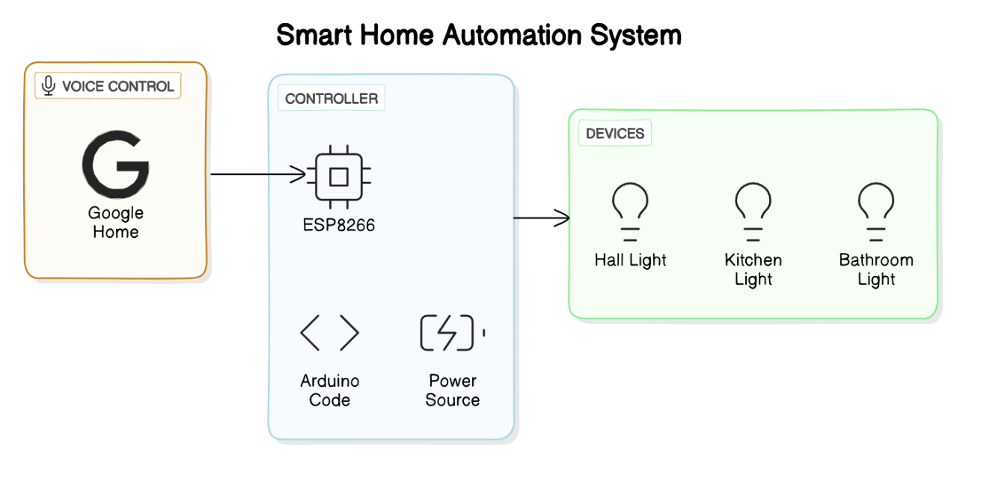

**Fig 4.1 System Architecture**

**4.2 METHODOLOGY**

The methodology for the project involves several key steps to design, develop, and implement the smart home automation system. Firstly, the hardware components, including NodeMCU microcontrollers, LEDs, breadboards, jumper wires, and 5V relays, are assembled and interconnected on a prototyping platform. This involves carefully wiring the components together using jumper wires and breadboards to ensure secure connections and proper functionality. Next, the NodeMCU microcontrollers are programmed using the Arduino IDE or a similar development environment to enable Wi-Fi connectivity and GPIO control. This includes writing code to interface with sensors, control actuators, and communicate with the Blynk platform for remote monitoring and control.

Following the hardware setup and programming, the system's functionality is tested and validated through a series of experiments and trials. This involves verifying the accuracy of sensor readings, testing the responsiveness of actuators, and ensuring proper communication with the Blynk platform. Any issues or bugs encountered during testing are identified and addressed through iterative debugging and refinement of the code. Once the system meets the desired performance criteria, it is deployed in a real-world home environment for further evaluation and feedback. Users are encouraged to interact with the system and provide input on usability, reliability, and overall satisfaction. Finally, any necessary adjustments or enhancements are made based on user feedback to optimize the system for practical use in a smart home setting.

**CHAPTER 5**

**RESULTS AND DISCUSSION**

The implementation of the smart home automation system yielded promising results, demonstrating its effectiveness in enhancing convenience, efficiency, and security for homeowners. Users were able to remotely monitor and control various aspects of their home environment through the Blynk mobile application, including lighting, temperature, and security settings. The integration of NodeMCU microcontrollers, LEDs, breadboards, jumper wires, and 5V relays provided a robust platform for seamless communication and control of connected devices. Additionally, the automation features offered by the system helped optimize energy usage and streamline routine tasks, reducing the need for manual intervention and improving overall home management efficiency.

The real-time monitoring capabilities of the system enabled users to stay informed about their home's status, receiving instant notifications of any anomalies or security breaches. This enhanced level of awareness contributed to a greater sense of security and peace of mind for homeowners, knowing that they could respond promptly to any unexpected events.

Furthermore, the scalability and flexibility of the system allowed for easy expansion and customization to accommodate evolving needs and preferences, ensuring long-term relevance and usability.

The successful implementation of the smart home automation system highlights the potential of IoT technologies to revolutionize home management practices. By leveraging affordable and accessible hardware components alongside cloud-based platforms like Blynk, homeowners can enjoy a more connected and intelligent living environment.

**OUTPUT**

**SWITCHING ON THE LIGHT GOOGLE HOME**

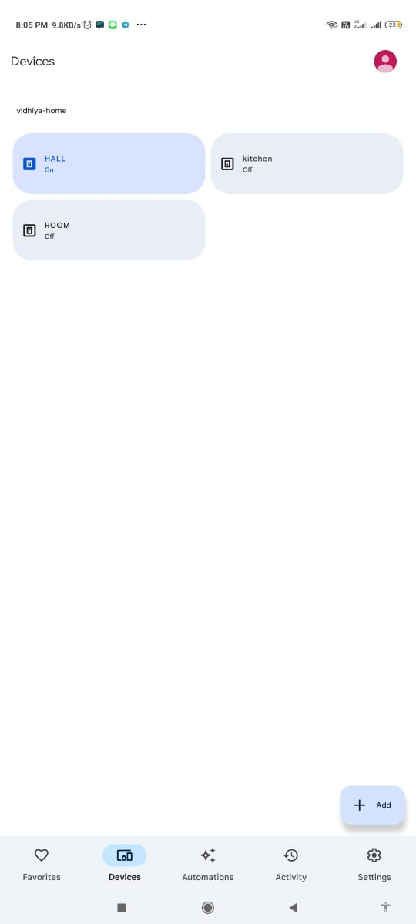

**OUTPUT**

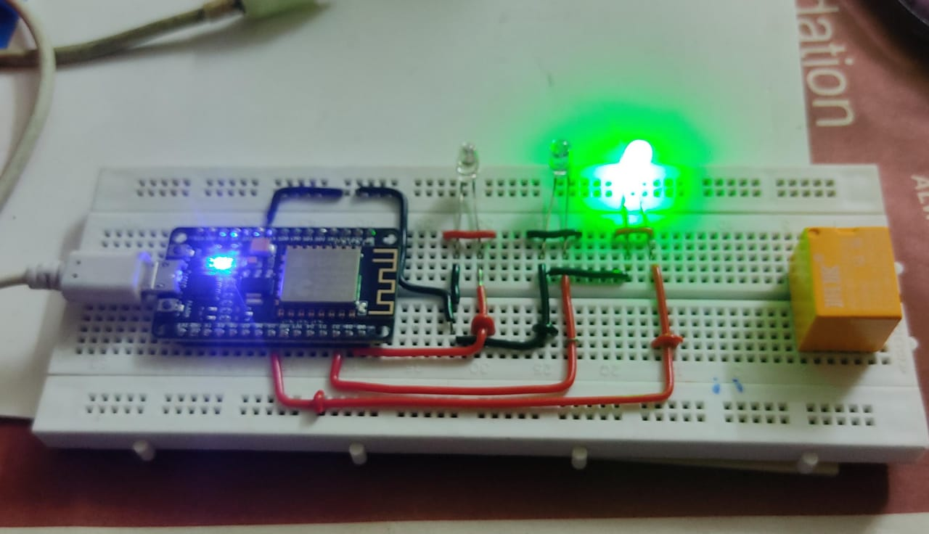

**CHAPTER 6**

**CONCLUSION AND FUTURE WORK**

* 1. **Conclusion**

The development and implementation of the smart home automation system represent a significant step towards revolutionizing traditional home management practices. By leveraging IoT technologies such as NodeMCU microcontrollers, LEDs, breadboards, jumper wires, and 5V relays, alongside the Blynk platform, the project has successfully demonstrated the potential for enhancing convenience, efficiency, and security in modern living environments. The system's ability to remotely monitor and control various aspects of the home environment, coupled with its automation features and real-time monitoring capabilities, offers homeowners a powerful tool for managing their homes more effectively. Moreover, the scalability and flexibility of the system ensure its adaptability to evolving needs and preferences, ensuring long-term relevance and usability. Moving forward, the insights gained from this project can serve as a foundation for further advancements in smart home automation technology, paving the way for a more connected, intelligent, and sustainable future.

Top of Form

# Future Work

* Integration of machine learning algorithms to enable the system to learn user preferences and autonomously adjust settings for optimal comfort and energy efficiency.
* Incorporation of voice recognition technology to provide an alternative user interface, allowing homeowners to interact with the system using natural language commands.
* Exploration of interoperability with other IoT devices and platforms to enhance compatibility and enable seamless integration with a wider range of smart home devices and services.
* Further refinement and optimization of the system's hardware and software components to improve reliability, performance, and user experience.
* Continued research and development to explore emerging technologies and trends in smart home automation, ensuring that the system remains at the forefront of innovation in the field.

# APPENDIX

# SOFTWARE INSTALLATION

**Arduino IDE**

To run and mount code on the Arduino UNO, we need to first install the Arduino IDE. After running the code successfully, mount it and install ESP8266 module.

# Sample code

#ifdef ENABLE_DEBUG

#define DEBUG_ESP_PORT Serial

#define NODEBUG_WEBSOCKETS

#define NDEBUG

#endif

#include <Arduino.h>

#if defined(ESP8266)

#include <ESP8266WiFi.h>

#elif defined(ESP32) || defined(ARDUINO_ARCH_RP2040)

#include <WiFi.h>

#endif

#include "SinricPro.h"

#include "SinricProSwitch.h"

#define WIFI_SSID "VDH"

#define WIFI_PASS "nonenone"

#define APP_KEY "5b422976-74ac-451e-ba27-fe7c076144ac"

#define APP_SECRET "e5bfc8a2-6f9f-40f9-9cbc-b95935848a46-0d2eb61a-f7c9-4cd0-ac0f-3ed3114450a7"

#define SWITCH_ID "6644573dfb874c7486d3260d"

#define BAUD_RATE 115200 // Change baudrate to your need

#define BUTTON_PIN 8

#define RELAY_PIN 9

bool myPowerState = false;

unsigned long lastBtnPress = 0;

/* bool onPowerState(String deviceId, bool &state)

*

* Callback for setPowerState request

* parameters

* String deviceId (r)

* contains deviceId (useful if this callback used by multiple devices)

* bool &state (r/w)

* contains the requested state (true:on / false:off)

* must return the new state

*

* return

* true if request should be marked as handled correctly / false if not

*/

bool onPowerState(const String &deviceId, bool &state) {

Serial.printf("Device %s turned %s (via SinricPro) \r\n", deviceId.c_str(), state?"on":"off");

myPowerState = state;

digitalWrite(RELAY_PIN, myPowerState?LOW:HIGH);

return true; // request handled properly

}

void handleButtonPress() {

unsigned long actualMillis = millis(); // get actual millis() and keep it in variable actualMillis

if (digitalRead(BUTTON_PIN) == HIGH && actualMillis - lastBtnPress > 1000) {

if (myPowerState) { // flip myPowerState: if it was true, set it to false, vice versa

myPowerState = false;

} else {

myPowerState = true;

}

digitalWrite(RELAY_PIN, myPowerState?LOW:HIGH); // if myPowerState indicates device turned on: turn on led (builtin led uses inverted logic: LOW = LED ON / HIGH = LED OFF)

if (SinricPro.isConnected() == false) {

Serial.printf("Not connected to Sinric Pro...!\r\n");

return;

}

// get Switch device back

SinricProSwitch& mySwitch = SinricPro[SWITCH_ID];

// send powerstate event

mySwitch.sendPowerStateEvent(myPowerState); // send the new powerState to SinricPro server

Serial.printf("Device %s turned %s (manually via flashbutton)\r\n", mySwitch.getDeviceId().c_str(), myPowerState?"on":"off");

lastBtnPress = actualMillis; // update last button press variable

}

}

// setup function for WiFi connection

void setupWiFi() {

Serial.printf("\r\n[Wifi]: Connecting");

#if defined(ESP8266)

WiFi.setSleepMode(WIFI_NONE_SLEEP);

WiFi.setAutoReconnect(true);

#elif defined(ESP32)

WiFi.setSleep(false);

WiFi.setAutoReconnect(true);

#endif

WiFi.begin(WIFI_SSID, WIFI_PASS);

while (WiFi.status() != WL_CONNECTED) {

Serial.printf(".");

delay(250);

}

Serial.printf("connected!\r\n[WiFi]: IP-Address is %s\r\n", WiFi.localIP().toString().c_str());

}

// setup function for SinricPro

void setupSinricPro() {

// add device to SinricPro

SinricProSwitch& mySwitch = SinricPro[SWITCH_ID];

// set callback function to device

mySwitch.onPowerState(onPowerState);

// setup SinricPro

SinricPro.onConnected([](){ Serial.printf("Connected to SinricPro\r\n"); });

SinricPro.onDisconnected([](){ Serial.printf("Disconnected from SinricPro\r\n"); });

SinricPro.begin(APP_KEY, APP_SECRET);

}

// main setup function

void setup() {

pinMode(BUTTON_PIN, INPUT);

pinMode(RELAY_PIN, OUTPUT); // define LED GPIO as output

Serial.begin(BAUD_RATE); Serial.printf("\r\n\r\n");

setupWiFi();

setupSinricPro();

}

void loop() {

handleButtonPress();

SinricPro.handle();

}

# REFERENCES

**[1]** Adewumi, A. A., Olorunshogo, S. S., Adetunbi, A. A., Olaniyi, O. M., & Ajayi, O. A. (2021). A Secure and Cost-Effective Home Automation System Using ESP8266 Microcontroller. International Journal of Computer Applications, 143(13), 1-8.

**[2]** Asim, M., Khan, M. J., Wadood, M. I., Irshad, A., & Khan, M. A. (2020). A Cloud-Based Home Automation System Using ESP8266 and Raspberry Pi. International Journal of Advanced Computer Science and Applications, 11(8), 632-640.

**[3]** Shahin, M., Rahman, M., Ali, A. M., & Islam, M. R. (2020, December). Design and Implementation of a Smart Home Automation System using ESP8266 Microcontroller. In 2020 International Conference on Electrical, Communication, and Computer Engineering (ICECCE) (pp. 1-5). IEEE.

**[4]** Lin, J., Yu, W., Li, Y., Li, Z., & Zhao, W. (2017, December). A NodeMCU-based smart home system with voice control. In 2017 IEEE International Conference on Smart Grid and Electrical Engineering (SGEE) (pp. 1-5). IEEE.

**[5]** Gowda, R. C., Krishna, M. N., & Pradeep, A. N. (2017). Voice controlled home automation system using Raspberry Pi and ESP8266. International Journal of Scientific & Engineering Research, 8(5), 1817-1821.